GRAFFITI: Graffiti is a form of artistic expression that is drawn.
On the back of your paper write your new bboy or bgirl name in graffiti style. It is usually in bold letters and bright colored. Take your time and make it interesting.
Examples:
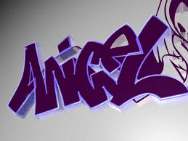
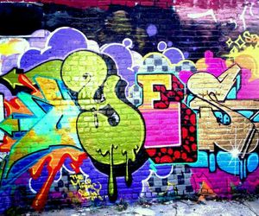
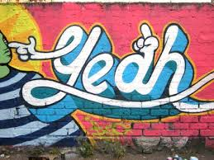
Rap Poems
A rap poem is a form of artistic expression that is created with words and spoken.
Use any type of rhyme below and fill in your 14 poem lines on your paper- no swearing or explicit talk!

Types of Ryhmes
- Semi-rhymes match up almost perfectly except for the fact that one of the words has an extra syllable (ex. “hate” and “grating”).
- Slant rhymes match only the end consonants, disregarding the vowel sounds (ex. “meant” and stint”).
- Forced rhymes match up sounds properly but throw off the natural rhythm by rhyming a stressed syllable with an unstressed syllable (ex. “stíng” and “sharing”).
- Visual rhymes match up words that look the same but sound different (ex. “dove” and “drove”).

Example poem starter:
Every day I am dancing from dusk until dawn,
I am so busy that I never have time to yawn,
Do not go knocking on my door,
I will be too busy break dancing on the floor,
Etc.

Popular Dance Moves
*Look up how to do these dance moves on youtube by Howcast and practice them!

1. the cabbage patch
2. the worm
3. the running man
4. the humpty dance

