1. Look at the shapes and names below.

Twisted

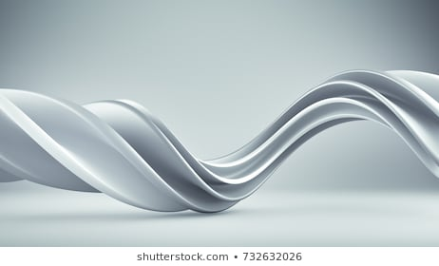

Curved

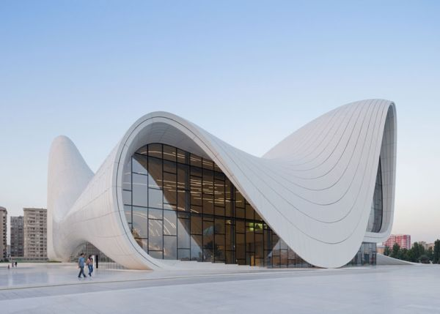

Straight

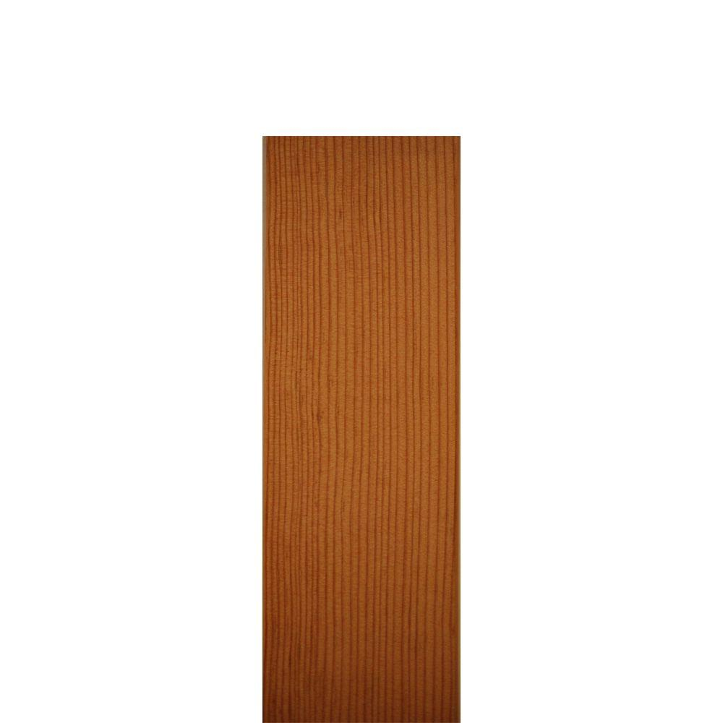

Angular



2. Name what shapes from above match each picture below and state why you chose that shape. Use each once.

__________



__________



___________



___________



Turn in your answers to Mrs. Tuckett and go over them with her.